
Author: David Gleich
Date: 23 April 2006


>> [d dt] = bfs(A);
>> [d dt ft pred] = dfs(A)

>> [d pred] = dijkstra_sp(A,u);
>> [d pred] = bellman_ford_sp(A,u);
>> [d pred] = dag_sp(A,u);
>> D = johnson_all_sp(A);
>> D = floyd_warshall_all_sp(A);

>> T = kruskal_mst(A);
>> T = prim_mst(A);

>> cc = components(A)
>> [cc a] = biconnected_components(A);

>> [flow cut R F] = max_flow(A,u,v);


We are distributing the library as a set of precompiled mex files for Windows and Linux. Hopefully these work for most people. In the event that the files do not work, we also distribute a precompiled .lib (Win32) and .a (Linux) file to recompile the mex files for another version of Matlab. Eventually, we plan to distribute the code behind the .lib and .a files.
If all goes well, installing the library is as easy as:
- Unzip the file matlab_bgl.zip. For the sake of example, let's assume you unzipped it into the same folder as I do: “/home/dgleich/matlab/” on Linux and “C:\Documents and Settings\dgleich\My Documents\matlab\” on Windows.
- In Matlab, add either the Linux path “/home/dgleich/matlab/matlab_bgl/” or the Windows path “C:\Documents and Settings\dgleich\My Documents\matlab\matlab_bgl” to the Matlab path (but replacing those directories with the ones where you actually unzipped matlab_bgl.zip).
To test the installation, try running the following script.
% add matlab_bgl to the path
% e.g. addpath(‘/home/dgleich/matlab/matlab_bgl’);
>> clustering_coefficients(sparse(ones(5)))
ans =
1
1
1
1
1


You should not need to complete the following steps.
In general, the precompiled versions should work. If they do not and you would like to try compiling the mex files from source, this section explains the process. On Windows, you must use a Microsoft Visual Studio compiler. The free Visual Studio 2003 Compiler Toolkit suffices for this purpose. On Linux, any recent version of gcc should work.
To compile the library from the .lib and .a files,
>> cd /home/dgleich/matlab/
>> cd matlab_bgl/
>> cd private
>> compile
If you cannot compile the library and the example does not work, please send email to mithandor@gmail.com with as much output as you can.


The Boost Graph Library is a powerful graph analysis toolkit. It contains efficient algorithms implemented as generic C++ template specifications. In the MatlabBGL library, we have wrapped these algorithms with mex functions which are callable from Matlab. The goal of the library was to introduce as little new material in Matlab as possible. As the next section explains, MatlabBGL uses the Matlab sparse matrix type as the graph type directly.
The idea behind the MatlabBGL library is to provide a rich set of graph-theoretic routines as efficient Matlab functions.


Matlab has a built in graph type: the sparse matrix. The goal of the MatlabBGL library is to use the Matlab sparse matrix as a graph type. To be slightly more concrete, we use a sparse matrix in Matlab to represent the adjacency matrix of two graphs from the Boost Graph library review of graph theory.
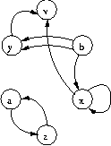
Figure 1: A directed graph.
For the graph in Figure 1, the adjacency matrix is
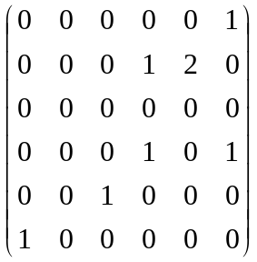,
and we labeled vertex a=1, b=2, v=3, x=4, y=5, z=6. In the original graph from Figure 1, there are two edges from b to y. We have replaced both edges with a two in the adjacency matrix. While this works for many algorithms, there are currently no ways of implemented true multi-graphs in MatlabBGL.
There are currently no multi-graphs supported in MatlabBGL.
We can construct this graph as a Matlab sparse matrix with the following set of commands.
>> A = sparse(6,6);
>> A(1,6) = 1;
>> A(6,1) = 1;
>> A(2,4) = 1;
>> A(2,5) = 2;
>> A(4,4) = 1;
>> A(4,6) = 1;
>> A(5,3) = 1;
>> labels = {'a';'b';'v';'x';'y';'z'};
Now, we can use the directed graph as a Matlab sparse matrix and as a MatlabBGL graph. As we will see, we can treat any square sparse matrix as a MatlabBGL graphs.
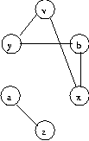
Figure 2: An undirected graph.
MatlabBGL requires that undirected graphs have symmetric adjacency. When constructing a graph, this means that you must specify each edge twice. The following Matlab session constructs the graph in Figure 2.
>> A = sparse(6,6);
>> A(1,6) = 1;
>> A(6,1) = 1;
>> A(2,4) = 1;
>> A(4,2) = 1;
>> A(2,5) = 1;
>> A(5,2) = 1;
>> A(3,4) = 1;
>> A(4,3) = 1;
>> A(3,5) = 1;
>> A(5,3) = 1;
>> labels = {'a';'b';'v';'x';'y';'z'};
An easier way of constructed the graph from Figure 2 is to take advantage of some of Matlab’s sparse matrix routines. We can use one command to add a reverse edge for each edge listed in a sparse matrix by executing
>> A = max(A,A’);
Using this command, we can build the undirected graph using the commands:
>> A = sparse(6,6);
>> A(1,6) = 1;
>> A(2,4) = 1;
>> A(5,2) = 1;
>> A(4,3) = 1;
>> A(3,5) = 1;
>> A = max(A,A');
In general, any square sparse matrix in Matlab is a MatlabBGL graph; the non-zeros of the matrix define the edges. If the sparse matrix is symmetric, then the graph is undirected.
Any square sparse matrix is a MatlabBGL graph.


In this section, we will address some fairly technical details of the implementation. Matlab implements sparse matrices as a set of compressed column arrays. Most adjacency matrix representations (and the one used in MatlabBGL) use the rows of the matrix to specify the edges from a particular vertex. That is, A(i,j) = 1 indices there is an edge between vertex i and vertex j.
Unfortunately, this means that in the Matlab compressed column storage format, we do not have access to the


We’ll show four examples of how to use the Matlab BGL library. The first three examples come from the Boost Graph Library samples. The last example shows how to write a new algorithm using MatlabBGL.


In the following example, we perform a breadth first search on an example graph from Boost.
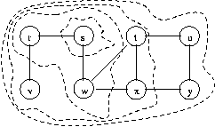
Figure 3: The breadth first search example graph from the Boost Graph Library. The concentric regions show the order in which breadth first search will visit the vertices.
We will load the graph from Figure 3 and compute the breadth first search (BFS).
>> load graphs\bfs_example.mat
>> [d dt pred] = bfs(A,2);
>> [ignore order] = sort(dt);
>> labels(order)
ans =
's'
'r'
'w'
'v'
't'
'x'
'u'
'y'
The first command loads the graph from the stored representation in Matlab. As we’ve seen, we present the graph as a sparse adjacency matrix.
>> full(A)
ans =
0 1 0 0 1 0 0 0 0
0 0 0 0 1 0 0 0 0
0 0 0 0 0 1 0 0 0
0 0 0 0 0 0 0 0 0
1 0 1 1 0 1 0 0 0
0 0 0 0 1 0 0 0 0
0 0 0 0 0 0 0 1 1
0 0 0 0 0 0 0 0 1
0 0 0 0 0 0 1 0 0
The second command runs the MatlabBGL bfs command starting from vertex 2. Looking at the label file, we can see that vertex 2 was really s in the original graph. The bfs command returns three vectors: d is a vector of the distance to each other vertex from s; dt is the discover time of each vertex, the time when the BFS first reached that vertex; and pred is the predecessor array encoded as a Matlab tree. In fact, we can view the predecessor array using the treeplot command.
>> treeplot(pred)
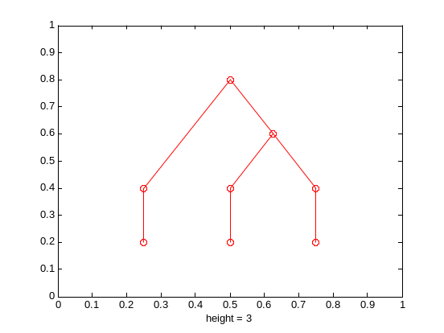
The third line of the example sorts the vertices by their discover time and saves the permutation of the indices. The permutation tells us how to permute the labels array to view the vertex labels in the discover order. The final line actually prints the labels in their discover order. Comparing with the original figure, we can see that the vertices were discovered in the correct BFS order.


In this example, we will compute a
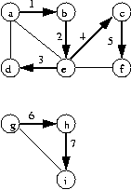
Figure 4: The depth first search example graph from the Boost Graph Library.


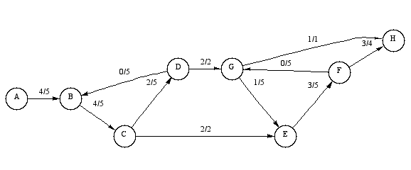
Figure 5: The max-flow min-cut example graph from the Boost Graph Library.




BFS Compute the breadth first search order.

[d dt pred] = bfs(A,u) returns the distance to each vertex (d) and the
discover time (dt) in a breadth first search starting from vertex u.
d(i) = dt(i) = Inf if vertex i is not reachable from vertex u.
pred is the predecessor array is used to construct the bfs search tree.

... = bfs(A,u,options) sets optional parameters (see
set_matlab_bgl_options) for the standard options.
There are no additional options for this function.

Note: this function does not depend upon the non-zero values of A, but
only uses the non-zero structure of A.

See also dfs


DFS Compute the depth first search times.

[d dt ft pred] = dfs(A,u) returns the distance (d), the discover (dt) and
finish time (ft) for each vertex in the graph in a depth first search
starting from vertex u.
dt(i) = ft(i) = Inf if vertex i is not reachable from u
pred is the predecessor array. pred(i) = 0 if vertex (i)
is in a component not reachable from u.

... = dfs(A,u,options) sets optional parameters (see
set_matlab_bgl_options) for the standard options.
options.full: compute the full dfs instead of the dfs of
the current component (see Note 1) [{0} | 1]

Note 1: When computing the full dfs, the vertex u is ignored, vertex 1 is
always used as the starting vertex.

Note: this function does not depend upon the non-zero values of A, but
only uses the non-zero structure of A.

See also bfs

http://msdn.microsoft.com/visualc/vctoolkit2003/
http://www.boost.org/libs/graph/doc/

